Web 2.0 Tools
Using digital platforms and innovative methods
in eTwinning project

I Teachers, pupils, parents - How do we communicate?
We communicate for a range of purposes and in many ways. The communication continuum shown here, as a way to understand the nature of a communication task. The continuum shows three ways of communication, 1 Way, 2 Ways and Multiple Ways.
This continuum is also a way to group and arrange your Web 2.0 communication tools, but this is just 1 way. You can group and arrange Web to 2.0 communication tools and other ways, based on your skills.
Let’s look at this continuum with some examples.
When a user wants to only present or share information and not receive replies, it is one-way communication. For example, a teacher may use Google Sites to create a website of student science projects for a science course to share with her students and their parents. Web 2.0 tools, like Google Sites, help teachers present and share information, mostly, in text and pictures, by creating websites.
Podomatic is another Web 2.0 tool that allows presentation and sharing of audio information.Feedly as an RSS tool that curates content based on suggested interest and field areas. These Web 2.0 tools provide one way communication, where information is provided by the creator, and there is no specific interaction with users.
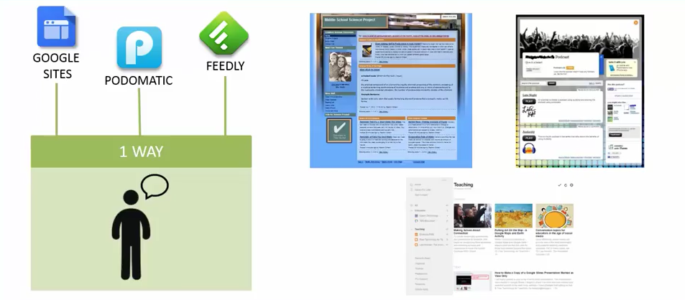
2 In two-way communication, a user can share information as well as receive responses from others. There is an interaction that is two-way in this type of communication.
For example, a teacher may use a poll, or a survey that’s embedded in her class presentation, using the Web 2.0 tool poll everywhere. Students in project can respond individually, using their mobile devices like cell phones. The poll can be displayed directly in the presentation so the teacher and the students can view immediate feedback. Other Web 2.0 tools that provide two-way communication are blogger, a blogging tool. And email tools like Yahoo Mail, Gmail or Microsoft Outlook.
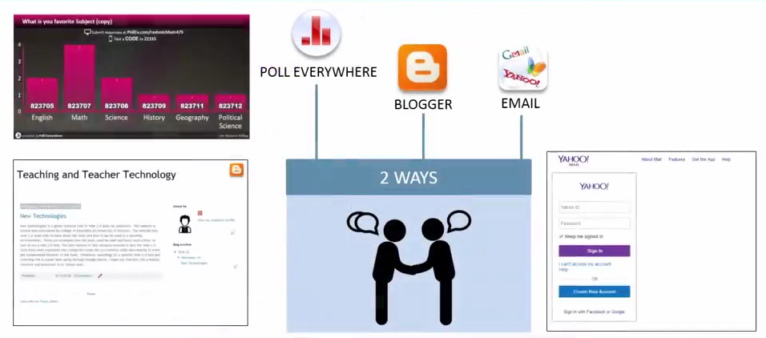
3 When more than two people want to establish communication back and forth, it’s said to be multiple way communication. The communication could be in real time or asynchronous. For example, students communicating on an issue might use an online discussion board like BoardHost or an audio conferencing system on Skype so they can discuss a project at the same time. Some of the other Web 2.0 tools that support multiple people communicating together are Google Hangout and Google Docs. These tools provide interaction between multiple parties that could be synchronous or asynchronous.
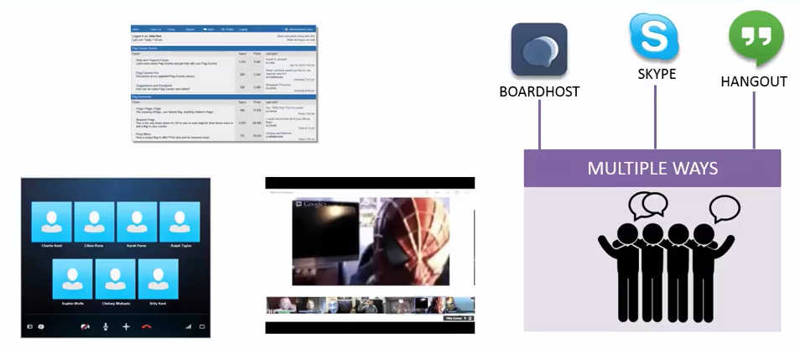
Remind101– Online tool for sending text messages to students, parents and Project partners.2
Google Hangouts– A video chat tool from Google. Accessible across different platforms and devices.3-
Penzu- An online tool for journal writing with simple navigation, a clean layout, and a high level of security.

II Energize Your Class with 2.0 Web Tools and innovative teaching methods
Animate Your Classroom with 2.0 Web Tools
“I never teach my pupils. I only attempt to provide the conditions in which they can learn” ~ Albert Einstein
Below are a list of 20 activities we can use to engage students. Let’s challenge us to try one of these ideas a week to help us bring our subject topic to life.
20 Ideas and Resources
#1. TOC (Table of Contents) – What do you know?
List the chapter titles on the board.
Under each title, students write down anything they know about the topic even if it doesn’t show up in the chapter.
Students stay around the board and guess who wrote what.
The student who wrote the info talks more about it.
This will get your students to tie prior learning to new learning they encounter for those chapters.
This would be easy to do on an interactive whiteboard or take pictures and upload to Evernote.
#2. Passing Notes
Before studying a topic, have students write what they know about the topic on a piece of paper or sticky note.
Students pass their notes to another student who has to write a question related to the information on the sticky note.
Students pass their notes again to a different student. This student finds the question or information in the chapter.
#3 Collaborative Class Bookmarking
Create a collaborative bookmarking account for students to contribute videos, links, blog posts, podcasts and other resources they find about the topic.
In the past my students used Pinterest, because it is visually interesting. Unfortunately, you cannot embed your Pinterest boards, therefore, I recommend Listly, Educlipper, PearlTrees, or Livebinder. All these tools are free, allow collaborative bookmarking, and have free mobile apps.
#4 Sticky Boards of Information
Before teaching a unit or chapter, create a sticky board using these free tools- Linoit or Padlet. Students don’t have to register. They just need the link to your wall to post information. With Padlet, you can password protect the wall. These walls are embeddable and accessible on mobile devices.
You can have students find specific information to post on the wall. For example, get students to find videos, podcasts, or images about the topic. You can challenge them to find real world examples or resources that are less than 2 years-old.
#5 Photo and Video Challenges
For each unit or chapter, you can post photo and video challenges for students. You can set these up through an Instagram or Flickr account. Basically, it will look like this- Challenge: Snap a photo of a fraction, then write a word problem inspired by this image.
#6 Students as Teachers
Divide students into small groups according to the number of sections of a chapter. Each group is responsible for teaching that section to the class. In the past, I’ve done this with my World Religions and History classes. Students followed checklists and guidelines. They had to create the assessment, have us participate in a ritual, give a short presentation and assign homework that was engaging (like play a game or respond to a video). Worksheets were not allowed. Each task was assessed by group members, the class, and me. I gave them examples of a good lesson before they did this. This was a project for later chapters so they could learn by my example.
#7 Use Word Cloud Tools
Divide the readings in the chapter. Each student is given a section and asked to create a word cloud with this text. Post these word clouds where each student can have access (a blog, wiki, the board). Each student reads the word clouds and must come up with a few questions they will seek the answer to in the text. Find several Word Cloud tools and ideas in my Pinterest board.
#8 Use Graphic Organizers
Various graphic organizers like the KWL chart are great for getting students engaged with information in a textbook! Check out a previous presentation and the resources I collected here.
#9 Create Concept Maps
Popplet is a collaborative online mindmapping tool and a free app on the iPad. Students can add images, videos, drawings, and links to support any topic. This can be exported or embedded for them to study later.
#10 Create/Play Digital Games
Have students create their own online digital games related to the topic. Find out how in my presentation, Level Up! Engaging Students by Having Them Create a Digital Game
#11 Play Classroom Games
Find a classroom game to make it interesting! Many games listed here in my Pinterest.
#12 Create/Play Board Games
Trivia Pursuit, Apples to Apples, Monopoly, Clue, Twister, and other board games are great ways to teach concepts from the book and get students moving.
Students can create their own board games related to the topics at Boggles World.
#13 Modernize Dialogues
Take dialogues or gap fills from the text and have students modernize them either through role-plays or with video creation tools like Go Animate, Ben and Tom Newsreporter, Sockpuppets and PuppetPals
#14 Make it into a Movie or Film Clip
Your students can create short films, movie previews, silent films and more. Discover the process in this presentation, 123 Action! Videography in the Classroom
#15 Use Polls
Poll students about chapter topics and post the findings to encourage discussion and debate. Students can create their own opinion polls or poll another class to collect data. They can use this data to create an infographic. Find several polling tools here.
#16 Create Infographics
Have students collect data through a Google form or other free survey tool or through research and show this through infographics. Find various lesson ideas in my presentation on infographics.
Piktochart is my favorite free tool for creating infographics.
#17 Create Your Own Textbook or Mini EBooks
Encourage your students to collaborate to create multimedia books of each chapter or as supplements to chapters.
They can store these online in Dropbox, on their desktops, mobile devices, flash drives or tablets so they have the materials everywhere they go.
Several free sites support collaborative writing! Check for examples and tools here!
#18 Create a Podcast
Your students can have ongoing radio shows or podcasts about the topics. Discover the process in this presentation, On Air! Audio Projects for Learners.
#19 Translate it into a Comic
Your students can translate sections of the book into a comic. See my student’s comic of Pride and Prejudice in slides 37-39.
#20 Invite a Guest Speaker
Have students learn from a guest speaker through Skype or Google Hangouts. Many parents would be thrilled to share their expertise or try calling up a local company and asking if they would visit your class v50 2.0 Web Tool Sites for eTwinning Projects
19 Pencils - 19Pencils is the easiest way for teachers to discover, share and manage web-based educational content with students. A teacher can create quizzes, websites, track students, and more.
ACMI Generator - This is a great site for older students for digital storytelling and creating a storyboard scene with a script.
20 Animoto - Create wonderful looking slideshows that includes, video, images, music, and more.

III Be safe! – How to teach pupils to be safe using digital platforrms?Aviary Education - A safe private environment to use Aviary's suite of online tools for: audio, video, and image editing.
BoomWriter - BoomWriter is a supremely engaging creative writing website that has students reading, writing and assessing content in ways they’ve never done before!
Classtell - A nice site for teachers to create an educational website.
Diigo - Social bookmarking for teachers where they can create free student accounts.
Dropbox - A great way to share and collaborate on documents on a number of different electronic devices.
Edmodo - A wonderful safe/secure learning environment for teachers and students. A nice all-in-one solution for education.
Educaplay - A excellent way to create interactive multimedia educational activities.
Every1Speaks - A learning platform where students learn through collaborative enquiry-based learning.
Gaggle - A excellent suite of online learning tools for filtered: emailing, messaging, forums, and more.
Glogster - Creating collaborative and interactive posters in this safe environment. A wonderful and very popular web 2.0 tool.
GoAnimate - A terrific way to create custom animations with an educational portal.
Google Apps for Education - Does it really get much better than this?
Gnowledge - A wonderful site to create collaborative online quizzes, share resources, view others quizzes, and more. Excellent tech support and tutorial videos as well.
Grockit Answers - A great teaching tool to create a Q/A session for any YouTube video.
Kidblog - A fantastic way to create a safe environment for students to blog in. Everything is controlled by the teacher as a moderator.
Kerpoof - Lots of educational activities can be found here such as: make a movie, draw a picture, and more.
Kubbu - A free site for teachers to create games, quizzes, or crosswords and then share them with students and view/analyze their results.
Little Bird Tales - A wonderful free site for digital storytelling that allows kids to record and narrate their story.
Live Binders - Is an excellent site for creating an online binder to collect and share resources with others.
MentorMob - One of my favorite new sites for curating the web into learning "playlists." This is an innovative way to teach a lesson, unit, or any given topic.
Mixbook - A great site for digital storytelling in a safe environment. Educators get a discount on printed books.
Musicshake - Legal, copyright, free music for every student in your school - created by students, right from a browser.
Myths & Legends - One of the best free sites around for digital storytelling in a safe environment with lots of characters, themes, and objects to choose from.
PhotoPeach - An excellent site for creating slideshows and creating and managing student accounts.
PikiFriends - A fun safe environment for online pen pals for middle school and high school students.
Pixton - A great way to motivate students by creating digital stories using this comic creator.
PresentationTube - A nice windows app for creating presentations out of PowerPoint slides.
Prezi - A excellent site for creating zooming slideshows and presentations.
Primary Access - A free suite of online tools for students and teachers to create digital movies, storyboards, and other activities.
Primary Wall - A real-time collaboration tool that allows students and teachers to create a page of online sticky notes. Great for mind mapping and brainstorming!
Skype in the Classroom - A great collaboration tool for classrooms to video or audio chat with other educators and students.
SideVibe - Turn bookmarked web content into blended classroom lessons.
SlideRocket - All you need is a Google Apps account to use this free tool to creating stunning presentations.
SpellingCity - One of the best sites around for teaching and learning Spelling and Vocabulary. A very user-friendly and engaging site to use.
Storybird - A fantastic site to inspire students to read & write through the use of digital storytelling.
StoryJumper - A great site for digital storytelling where students can incorporate their own art, publish online, share with others, or order a print copy.
SymbalooEDU - A wonderful way to organize educational sites into one location for students.
Triptico - A great free tool for teachers to help create, share, and edit interactive lessons.
ToonDoo Spaces - Create a private and safe environment for digital storytelling through the use of an online comic.
VoiceThread - One of the most popular web 2.0 sites around for creating dynamic and interactive slideshows and presentations. Also, another great tool for digital storytelling.
Webspiration - From the creators of Inspiration comes this excellent web portal for creating mind maps, brainstorms, outlines, and more.
Weebly - Create a free class/student blog or website.
Wolfram Alpha - There is now an educational portal for Wolfram's computational search engine. This portal contains dynamic textbooks, lesson plans, widgets, interactives, and more.
Yacapaca - A nice free all-in-one solution for schools for creating quizzes, surveys, assessments, and more.
YouTube for Schools - Access 1000s of YouTube videos in a controlled environment without having to worry about comments.
Zimmer Twins - A great site for digital storytelling with an educational portal.
Zoho Wiki - A nice site for educators to create online interactive content.
Cobblearning: free Edublogs for teacher’s class blog
Blackboard
Edmodo – Vitural classroom…. Powerful tool!!! Collaborate, communicate, research, assess, share, etc. with students and teachers
- Remind – Reminders are sent to parents and students.
- Portfoliyo – Send parents reminders from a computer.
- WikiSpaces – Place to share resources and students can publish work
- Smore: online flyers… that can be shared on the web. Make a QR code for an event. Very professional looking and easy to use.- Voki - Jazz up a PBL Task Page, Class Blog &/or Web page. (Personalized speaking avatars)
- Tackk - online creation tool... seamless login via Edmodo
- Canva - Great visual tool for logos, invitations, cards, etc.
- Linoit.com – A place to collaboratively brainstorm and post learning.
- Padlet (was called Wallwisher) – Similar to Linoit. - - It is the digital example of sticky notes on a wall. SO many ways to use with students.
- Stormboard - similar to Padlet... more for MS/HS
- Google Docs – Forms, Spreadsheets, documents, presentation… great place to store and collaborate with others
- OneDrive - Online Microsoft docs - Word, Excel, PowerPoint, OneNote
- Blendspace AKA Edcanvas Example of How to Use for a Flipped Classroom Example for Reading
- Thinglink Math Example
- Weebly – free Web sites
- Spicynodes - Webbing and sharing information
- Stoodle - collaboration tool
- Mozilla's Popcorn Maker - Popcorn Maker helps you easily remix web video, audio and images into cool mashups that you can embed on other websites. Drag and drop content from the web, then add your own comments and links —all within your browser. Popcorn Maker videos are dynamic, full of links and unique with every view.

IV Skill Practice/ Assessment Tools:
SkillsTutor - Online homework, one-on-one tutoring, pre-tests, test prep, differentiation, remediation…. Free to CCSD teachers.
ScootPad – Online homework…. Save trees! Practice and learn CCGPS for students… set up classs and keep up with student productivity and progress.
Socrative – (See below in BYOD)
Rubric Maker
RCampus – Rubric Maker
Checklist Maker
JogNog Quick Quizzes – How to blog post
Bubblr – Interactice quizzes using YouTube clips (Background information)
Zondle
Kahoot
Quizizz
Shmoop Online Tools
Classtools.net - Connect Four - review game
Padlet Padlet Tutorial
Five FAST Formative Assessment Tools
Team Maker
BouncyBalls - - classroom management - balls bounce based on level of noise in the classroom.

